## Creating a Cucumber Feature File:

1. Create a simple text file with the extension .feature
2. Save this feature file in the appropriate location under src/walgreens/ecom/batch/automation/staging/features/{TestingArea such as functional,regression}
3. Add the feature level tags to the top of file, which can be used to run all the scenarios within this feature file such as: @loyaltyShoppingCart
4. Under the top level feature tag, write the general description of the feature using the Keyword “Feature” such as:
   1. Feature: All the scenarios in this feature are to validate the Loyalty Check Points within Shopping Cart Page

## Creating a scenario:

1. Under the Feature file description, write the first scenario’s tag – For example: @LTY-CART-1
2. Under the first scenario’s tag, write the description of the scenario using the keyword “scenario” – For example: Scenario: Non-Loyalty customer adds daily living Bogo product to cart and validates the savings in the shopping cart
3. Under the scenario description, add individual steps by using the keywords such as “Given”, “Then”, “And” etc.
4. There are two ways, data can be provided for a step:
   1. Excel Sheet: If a step has a shared across many scenarios, then the data should come from Excel sheet. This will provide the benefit, when a data gets currupted and many scenarios are relying on that data. So, updating it at one place will fix the data issue for all these scenarios. For example, Lets say, many scenarios are using a product that needs to be searched and added to the shopping cart. However, this product is not showing in the serach results any more. So, you just have to pick a different product and update it within the Excel sheet and all of the Scenarios relying on that product will start working.

Here is a sample Step that is using Excel for data:

And "LTY-CART-1" Customer searches for a product using keywords in the search textbox:

| InputFileName | SheetName | RowId |

| CommonData | search | loyaltysave1 |

Here is the corresponding Excel data for the above step:

|  |  |  |
| --- | --- | --- |
| ID | **Keyword** | **Keyword2** |
| loyaltysave1 | prod3869017 | Pert PlusClassic Clean 2 in 1 Shampoo |

* 1. Direct Step data: The data can also be specified under a step, if the data is not dependent upon any external system. For Example:

And "LTY-CART-1" Customer finds Loyalty Information in the Order Summary Box on the shopping cart page:

| LoyaltySavingMessage | LoyaltyBonusPointsMessage |

| Yes | No |

## Running the Cucumber Scenario(s)

1. To run all the scenarios in the feature file use the feature level tag in the following command:

EcommTestRunner @loyaltyShoppingCart regression

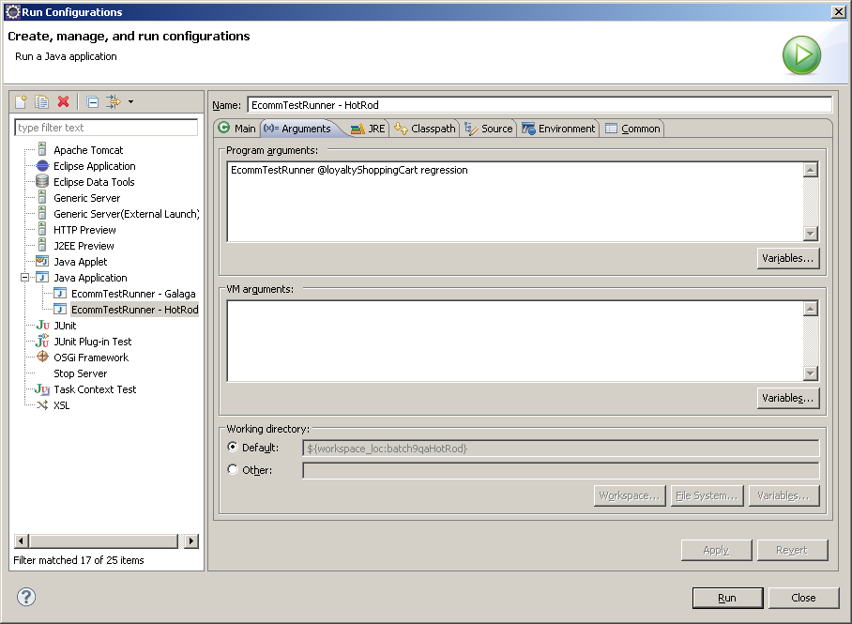

1. To run a single scenarios from a feature file use the scenario level tag in the following command:

EcommTestRunner @LTY-CART-1 regression

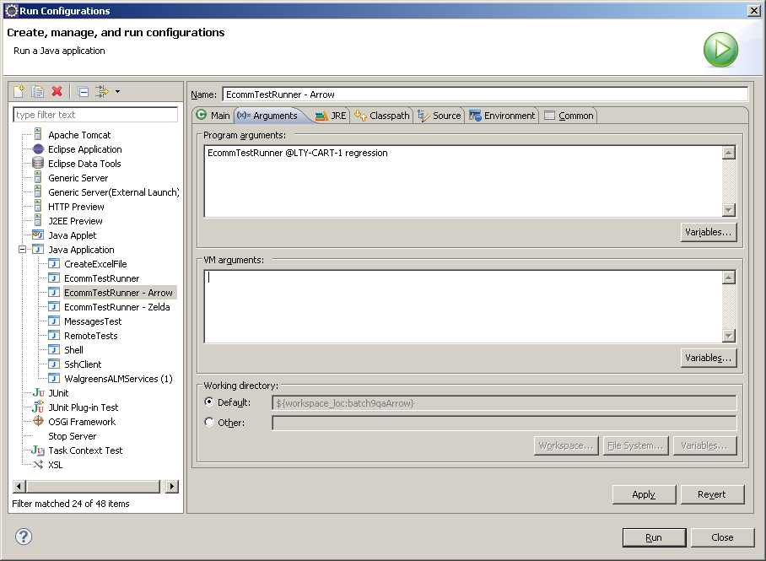

## Cucumber Report:

After completely running the scenario, the cucumber report will show up in the following directory, whereas “07-10-2012-14-20-05” is the timestamp when this scenario(s) ran. @loyaltyShoppingCart is the tag that was used to run the scenario(s). “fireFox” is the browser, which was used to run the scenario.

report/cucumber/staging/regression/07-10-2012-14-20-05/@loyaltyShoppingCart/fireFox

In cases, where some scenarios fail, there will be an additional file show in the following directory called Failure.txt, which is going to have the information about the failing scenario/step/browser etc. This is created for tester’s convenience, so that they don’t have to go through the entire Report to find out which scenarios have been failed.

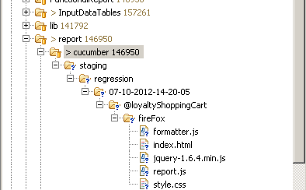

## Excel File Location that are going to hold the data:

For Functional Testing in Staging: InputDataTables/staging/functional

For Regression Testing in Staging: InputDataTables/staging/regression

